Week Ending: |  | DAY: |  |  |  | Subject: History
Duration: 60mins per lesson |  |  |  |  |  | Strand: Independent Ghana
Class: B6 |  | Class Size: |  |  |  | Sub Strand: Military Rule
Content Standard:  B6.6.2.1. Understand that military takeovers interrupted constitutional rule on four occasions since 1966, with some consequences |  |  |  | Indicator:  B6.6.2.1.1 Identify the leaders of the coup d’états and names of their regimes |  |  | Lesson:  1 OF 1
Performance Indicator:  - Learners can identify the leaders of the coup d’états and names of their regimes |  |  |  |  | Core Competencies:  Learners to become critical thinkers and digital literates
Teaching/ Learning Resources |  |  | Wall charts, word cards, posters, video clip, etc.
New words | protest, opposition, movement, nationalism, nationalist, elite, Bill, delegation, prevail,
References: History Curriculum Pg. 45
DAYS | PHASE 1: STARTER | PHASE 2: MAIN | PHASE 3: REFLECTION
 | The teacher brings a bag into the classroom that contains an object that has a connection to the lesson.  Then it is passed around and learners try to determine what is in the bag just by feeling it.  The student who guess right wins, and hence introduce the lesson  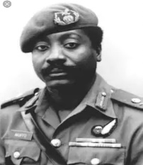 | Guide learners to explain the terms coup d’états and military takeovers with examples.  Show and discuss a documentary on any of the military take overs.  e.g. Major General William Kwasi Akuffo  William Kwasi Akuffo born on 21 March 1937, was a soldier and Politian. He was a chief of defense staff of the ghana armed forces and a head of state and chairman of the ruling military council in Ghana from 1978 to 1979. He came to power in a miliatry coup against the govenrment of Kutu Achempong, was overthrown in another military coup and excuted three weeks later. | Ask learners questions to review their understanding of the lessson.  Give learners task to do whiles you go round to guide those who need help.
 | The teacher brings a bag into the classroom that contains an object that has a connection to the lesson.  Then it is passed around and learners try to determine what is in the bag just by feeling it.  The student who guess right wins, and hence introduce the lesson | Guide learners to explain the terms coup d’états and military takeovers with examples.  Show and discuss a documentary on any of the military take overs.  e.g. Flt Lt. Jerry John Rawlings  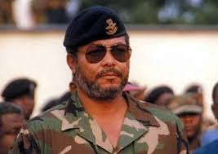 | Ask learners to summarize what they have learnt.  Let learners say 5 words they remember from the lesson.

